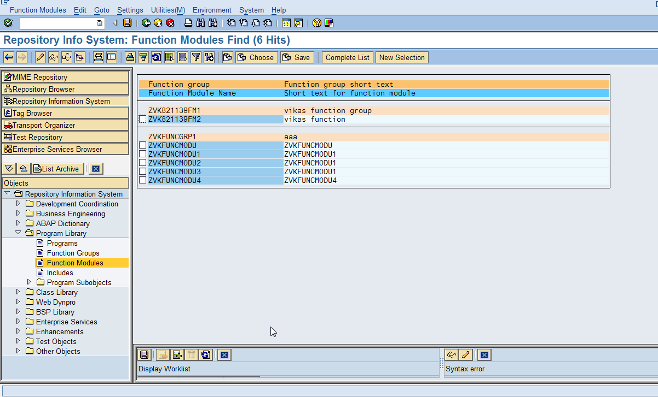

Double clicking on Function Module will show code for Function Module. We can then test it.